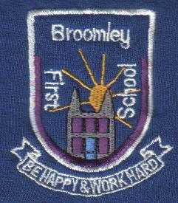
Year One Information and Curriculum meeting
Your Child’s Teachers:
- Monday Miss Richardson
- Tuesday-Friday Miss Savoury
- Monday – Friday Mrs Dickinson & Mrs Gilholme
(Miss Wilson Tuesday and Thursday am)
- Wednesday –Mrs Swan, Mr Thompson
Class Routines:
Monday – Miss Richardson (Outdoor learning)
Tuesday – Yoga
Wednesday – PE, Ukulele, Homework Return
Thursday -
Friday – PE, Spelling Test, New Homework
Home/School Reading books can be changed daily, please keep yellow book in book bags.
Spelling – New lists given on Fridays. Please choose two/three spellings to put into sentences. Spelling, grammar, punctuation and handwriting are all important.
Reading – Please return reading books and yellow books each day. Please aim to read at least one book each week.
Math’s Challenges – Count to 100 forwards/backwards in ones. Count in multiples of 2, 5, and 10. Calculate (+ and -) using numbers to 20.
Additional Topic Enrichment Half Term Project – Space and Beyond! (Optional)

