**Our Safeguarding Children Team**

Designated Safeguarding

Governor

Name: Denise Kendall

Title: Safeguarding Governor

Designated Safeguarding

Deputy



Name: Amy Shepherd

Title: EYFS Lead

Designated Safeguarding

Lead

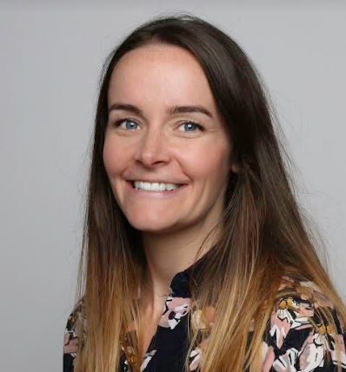

Name: Kelly Howe

Title: Executive Head Teacher

Designated Safeguarding

Deputy

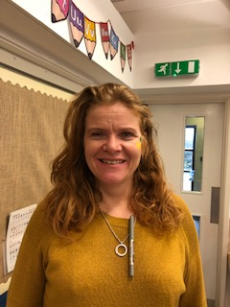

Name: Sam Drysdale

Title: EYFS Teacher & SENDCo

September 2022

**If you are concerned about a child please talk to us**

**I have a safeguarding concern relating to a child, parent or member of staff**

**Our Safeguarding Children Process**

**Write down your concern on a cause for concern sheet**

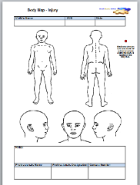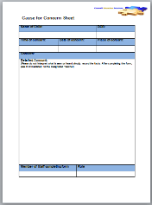



Designated Safeguarding Lead



Name: Kelly Howe

Title: Executive Head Teacher

Designated Safeguarding Deputy



Name: Amy Shepherd

Title: EYFS Lead

Designated Safeguarding Deputy



Name: Sam Drysdale

Title: EYFS Teacher and SENDCO

Designated Safeguarding Governor

Name: Denise Kendall

Title: Safeguarding Governor

Where appropriate the Designated Safeguarding Lead will give feedback. In some incidences the case details may be confidential

**Inform a member of the Safeguarding Team**

Other useful contacts:

**NSPCC**

**Tel: 0808 800 5000**

**Children’s Social Care**

**Tel:** 01670 536400

**Police**

**Tel: 101 (non emergency)**

**Tel: 999 (emergency)**

**Feedback to the referrer**

**Advice will be given on the next steps**

**A plan will be put in place**

This may or may not involve a referral to Social Care

This may or may not involve actions to be taken by the referrer