Bulletin  Number  3 | Whittonstall and Broomley First School Federation      “Work hard and be happy”   | 21st  September 2018
Tel: W: 01207560325 B: 01661842271 Website:www.broomley.northumberland.sch.uk/website

Our overall attendance this week was

97.20%
We really appreciate all your efforts in getting to school on time, ready to start our day promptly.
Keep up the good work!

DEPUTY HEAD TEACHER’S MESSAGE: It has been a very windy week in school this week and we watched from the windows as the leaves swirled around like whirlwinds on the playground! I would like to say a big well done to our Reception children on completing their first full week in school - they have been superstars!
I have seen some super sport around school this week from Golf coaching to Magpie Sports club, tennis, karate, dance workshops and our own excellent P.E. sessions. We are very proud of the different opportunities we are able to give our children. It has also been nice to hear the sounds of music in the corridors with the start of our ukulele lessons and individual music lessons this week! I have sent out information about Spellodrome this week too and hope to have it all up, running and ready by the end of next week.
Thanks to those who came to our phonics and SPaG workshops this week, we hope you found them useful! Look out for other parent workshops and information throughout the year. You can find some additional information on all of the grammar terms in a parents’ glossary on our website.

We hope to see many of you at our Macmillan coffee morning next week – see below for more information! Have a lovely weekend.

COMMUNITY NEWS AND EVENTS: Looking for something to do in the coming weeks:-





The Theatre Royal is offering a new term of weekly workshops for young people which are on sale now!
The theme this year is “A New World” - the groups will be devising performances that look back 100 years to the end of WWI when a new world of medical & technological advances began, before performing them in week 10. The cost per term is £65 and there are 10 sessions (with a 3 week break):
- 5-7 YEARS (A) - SATURDAYS 10.00 - 11.30am, starting 29 September and ending 22nd December
- 5-7 YEARS (B) - SATURDAYS 12.00 - 1.30pm, starting 29 September and ending 22 December
- 8-11 YEARS - FRIDAYS 5.00 - 6.30pm, starting 28 September and ending 21 December

____________________________________________________________________________
SCHOOL NEWS AND EVENTS
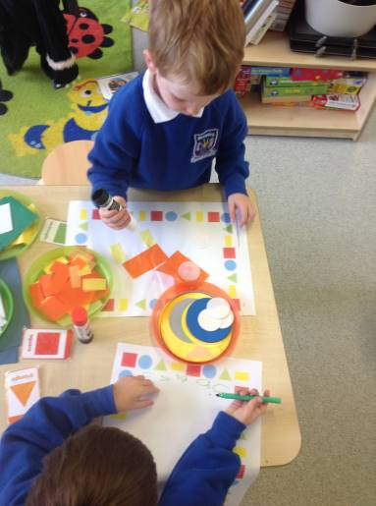
Reception: This week we have been talking about families and what makes them special, from playing Lego together, to going on bike rides to baking cakes and so much more. On Tuesday we shared the story, ‘The Rainbow Fish.’ It reminded us how important it is to share and how being kind makes us feel happy! We enjoyed the story so much we decided to make our own special rainbow fish which you can see in our EYFS corridor.
On Wednesday we had a brilliant P.E lesson. This week we really enjoyed exploring the tennis rackets and even managed to get a rally going! We also enjoyed using the bean bags to practice our throwing and catching and the hula hoops are always a favourite.
On Thursday we explored 2D shape in our Mathematics sessions. We have focused on naming and describing rectangles, squares, triangles and circles. We have used the mathematical vocabulary ‘sides’ and ‘corners’ to describe the shapes. We had so much fun going on shape hunts around school and found lots of shapes in the environment. We made shape monsters out of playdough and shape aliens with ‘gummed’ shapes.
This week we also started our ‘Autumn Days’ topic. We started by reflecting on what we already know about Autumn and then we decided what we would like to find out! We want to investigate why leaves change colour and fall off the trees, why squirrels hide their nuts, and why it gets cold.
We love using conkers as part of our continuous provision, to support with counting in maths and to use in art work. Our current ‘supply’ is running low! If you happen to see any conkers when you are out and about we would be very grateful if you could collect some for us to use in class.
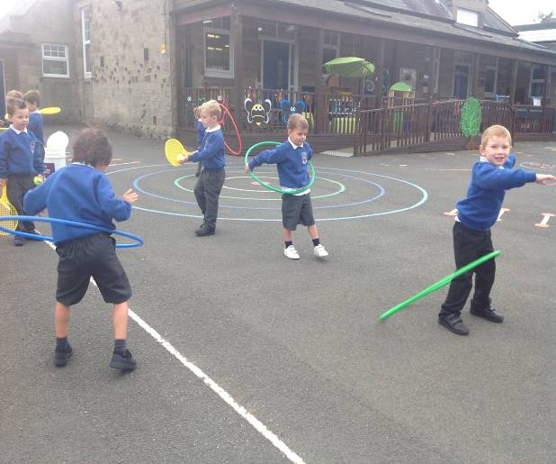
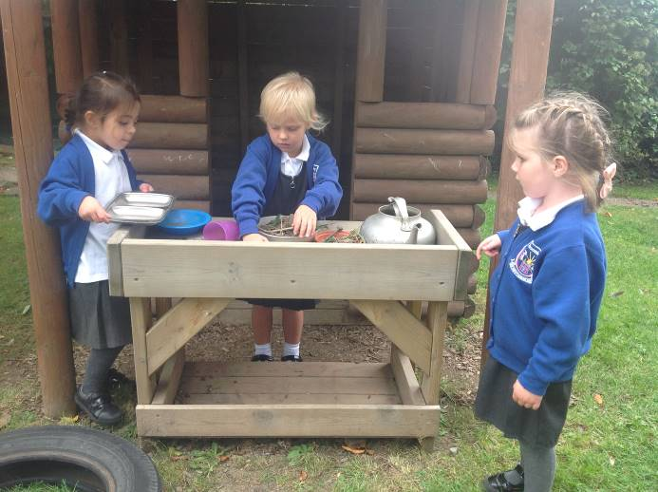

Year 1: In our outdoor learning this week we have been finding, ordering, sorting, grouping and sequencing numbers using natural objects. We extended this work in to the classroom too where we have been finding ‘one more’ and ‘one less’ than given numbers. We have also been exploring different ways to prove that a statement is true using numicon, coins and other maths materials.
In our English work we have written postcards from the moon as well as writing some instructions for the aliens in our story on how to make a cheese sandwich! We have also been using describing words - adjectives - to add description to our sentences e.g. The Moon is very dusty and dark. Bob goes to The Moon in a big space rocket. The aliens look green and slimy.
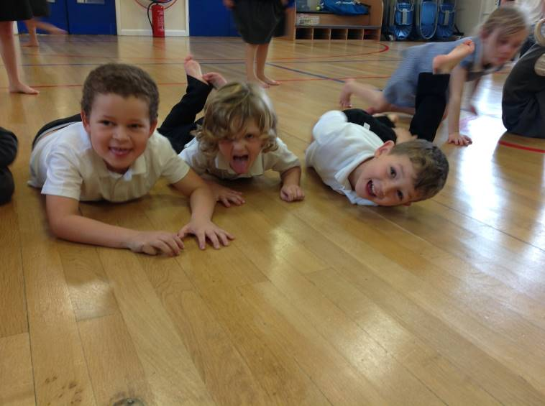
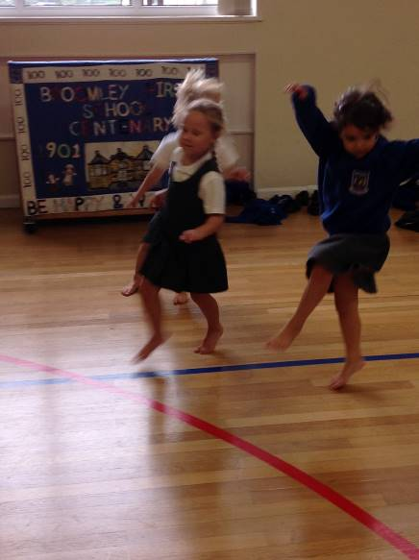
We also started our ukulele lessons this week and Miss Humble was very impressed with our natural ability. We learned to hold the ukulele in a rest position after strumming. We also started our dance workshops based around the jungle dance. We tried out different ways of roaming through the jungle! Mrs Gray has been really impressed about how much we know about astronauts, we leaned lots of new facts about how hard they have to train and what they need to learn. We even watched some real life videos of astronauts eating in space, sleeping in space and even how to have a wee in space!

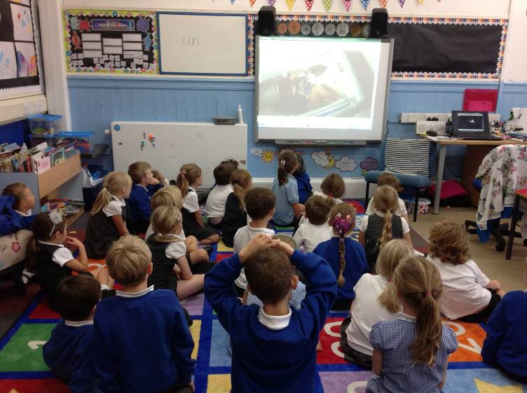
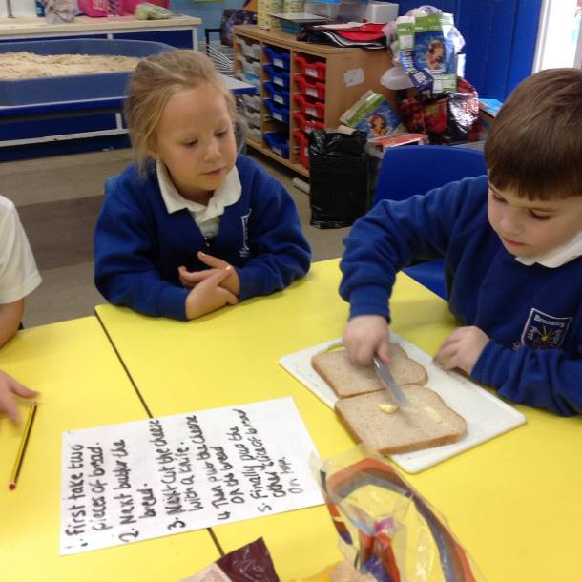

Year 2: This week Year Two enjoyed a fun filled day in the woods. The children had great fun making dinosaur nests and medals, toasting marshmallows and making apple crumble.
In English the children worked very well in perfect partners to spot verbs from the ‘Monstersaurus’ text and even suggested their own adverbs to improve this story.
In maths this week the children have continued to explore number and place value by arranging a set of digits to create as many 2-digit and 3-digit numbers as possible and by partitioning numbers into tens and ones.
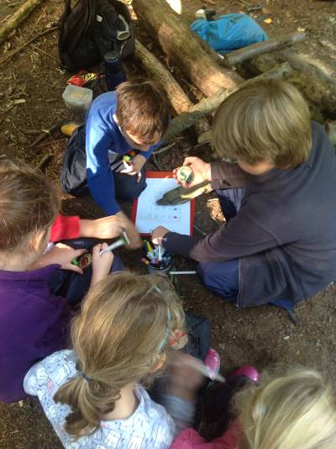
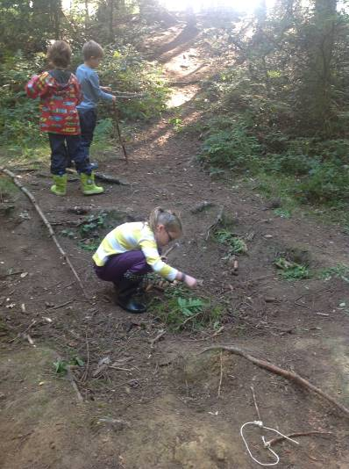
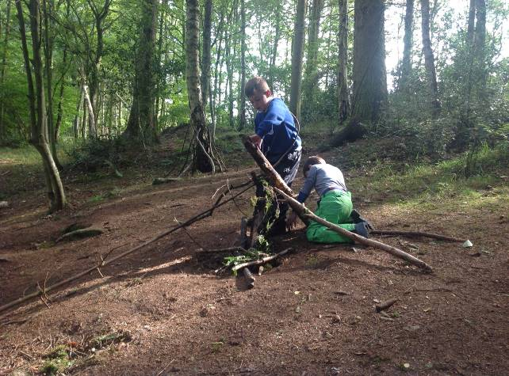

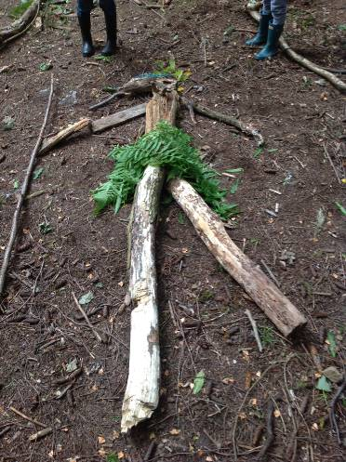
Year 3: Year 3 started the week in the woods and we had the lovely treat of Miss Richardson coming with us! Everyone got the chance to do lots of different things - cooking soup, making pancakes, designing woodland games, using bowsaws and drills to make woodland medals and designing our own woodland God or Goddess. It was super to see everyone working well together and showing just how much we enjoy our forest school trips. On Tuesday the class were taught by Mrs Burke because Mr Moore took the Year 2 children on their forest school trip. Wednesday saw everyone brave some early blustery conditions in PE, before retiring to the hall to complete their basketball skill lesson.
Handwriting sheets will come home this week - as mentioned in the curriculum meeting, this is for practise only and does not need to be returned to school. This week also sees the start of our 'sharing books' coming home. Half the class will get a book this week, followed by the second half of the class next week. The children know all about these books and Mr Moore hopes the whole family enjoy them over the weekend. Please ensure the books are returned on Monday, ready to go to the next child.

Please could I also ask for your help in encouraging the children to line up quietly at morning drop off, once the bell has gone? The class should be ready to go into school and at the moment many continue talking in large groups and ignore requests to line up smartly. We are having a real push with listening skills and Year 3 do need to work on this, starting at 8:55. I appreciate your help with this matter.

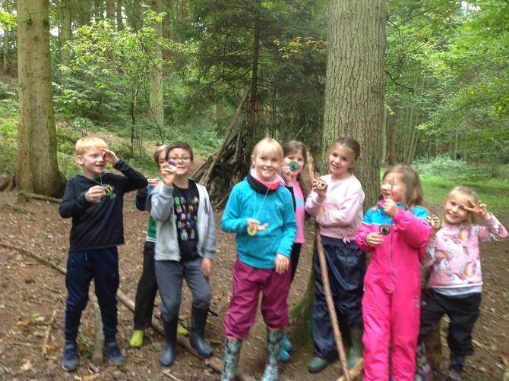
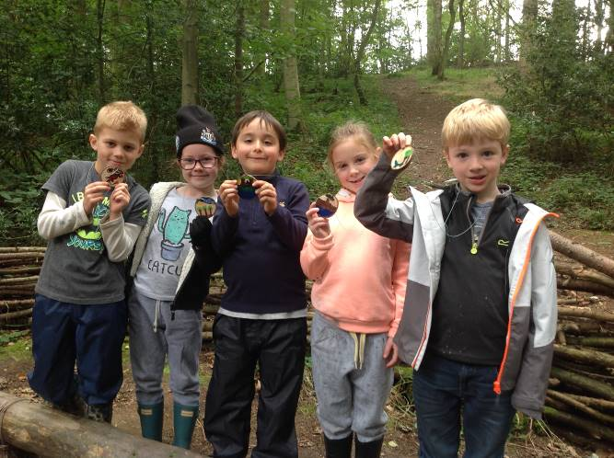
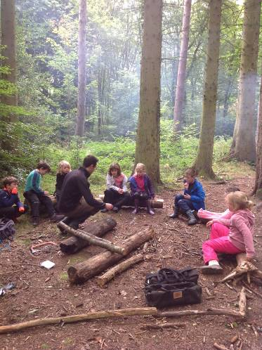
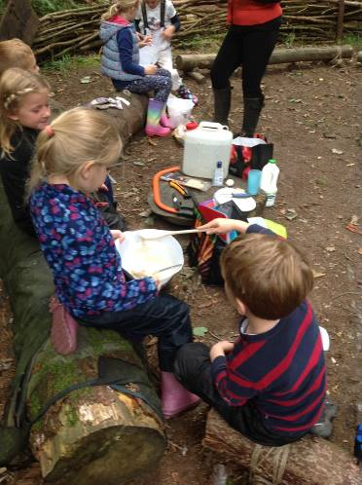
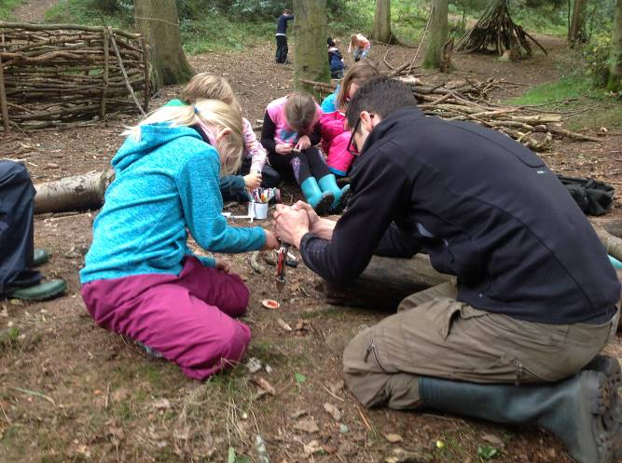

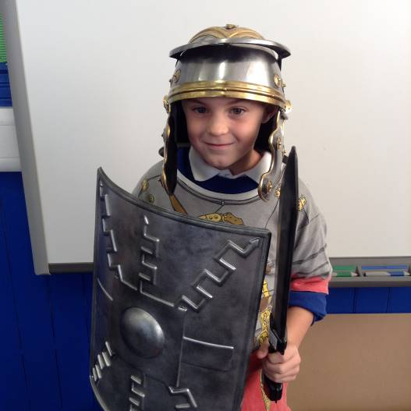
Year 4: This week, the class have been reading Aesop’s Fables and matching the moral to the correct story. During maths they have been extending their understanding of 4 digit numbers and also rounding to 10, 100 and 1000. We have also been practising our times tables and multiplying multiples of 10.

During our topic time we have been finding out about the Roman army and the kit the average soldier would need to carry. We have also been finding out about the very successful battle tactics that they employed.

MEMOS AND REMINDERS

School Photos – Friday 28th September: The children will all be having individual photographs taken next Friday when the school photographer, Tempest, comes in. If you would like your child to be photographed with their sibling, please return the slip sent home earlier this week. The photographer will be in the school hall from 8.30am and any parents with pre-school aged children are welcome to come in then and have a family group photograph taken. Other sibling groups – where the children are all in school, will be done with the individual photographs.


Macmillan Coffee Morning – Friday 28th September: We will be holding a coffee morning for parents, family members and friends to raise funds for Macmillan Cancer Care next Friday morning from 9.00am. As the photographer will be in the hall, the coffee morning will be held in the school canteen. We would be very grateful for any donations of cakes to help us make the morning go with a swing. The children will be able to buy any left-over cakes in the afternoon – to ensure they don’t spoil their lunch. We will be selling the cakes for 50p if they would like to bring some money in with them. We hope you are able to join us and if you are able to volunteer to help, we would be very grateful for your support – just let the school office know.
We would also like to let you know that George Mainwaring, one of our Year 3 boys, is going to ‘Brave the Shave’ and have his head shaved in school to raise money for Macmillan and Team Oliver. If you would like to sponsor George, either catch Lizzie Mainwaring in the school yard or follow the link: http://www.justgiving.com/George-Mainwaring7?utm_id=25

Data Collection Sheets: Data collection sheets have been sent home with your child this week. Please could you check the information and sign and return the forms to school by Monday 1st October. It is very important that we hold the correct information for your child including addresses, phone numbers and medical information. You would be amazed at how many families move house or change their phone numbers without telling us.

Current After-School Clubs:
Time | Group Leader | Year Groups
Monday Dance Club – 3.15-4.15pm | Molly Stroyan – (tel 07943804161 0r e-mail mlstroyan@yahoo.co.uk) | Open to all years
Tuesday – Cricket Club – 3.15pm – 4.15pm | Thomas Cant / Mr Hammersley (contact school office for more details) | Open to Year 2, 3 and 4
Wednesday Lunchtime - Magpie Sports Club - 12.30pm to 1.00pm | Mr Thompson (contact school office for more details) | Open to Year 1 and 2
Wednesday – 3.15pm to 4.15pm – Karate Club | Mr Peter Atkinson (tel or text 07912 533164) | Open to Year 1 – Year 4
Wednesday - Drama Club – 3.15pm to 5.00 pm | Miss Humble (contact school office for more details) | Open to Year 2, 3 and 4
Thursday – Tennis Club 3.15pm – 4.15pm | Mr Tom Geary (tel 0781 706 1898) | Open to all years
Friday – Magpie Sports – 3.15pm to 4.30pm | Mr Thompson (contact school office for more information) | Open to Years 2, 3 and 4


Whittonstall and Broomley Drama Club: Miss Humble, our music teacher, is hoping to run an after school drama club again this year for our Year 2, 3 and 4 children. The club will run each Wednesday from 3.30pm to 5.00pm from 26th September assuming we get enough interest, for both the Autumn and Spring terms and the children will then give a final performance around Easter time. The children will therefore need to commit to attend the club for both terms.
This year the chosen show is "The Rocky Monster Show" –‘Bizarre, anarchic and very funny, this Rock 'n' Roll musical is a riotous mix of the Addams Family, Young Frankenstein and Phantom of the Opera. Baron Frankenstein's descendant, and ex-pop star turned professor of Genetics, creates DNA moulds of people in his computer. How these moulds come to life as the ultimate Rock Group, headed by a clone of Elvis himself is the highlight of the hilarious plot’.
The cost of the club will be £40 per term and it will run for 10 weeks each term (£4 per session) culminating in the performance at the end of the Easter term. Payment will be required at the start of each term and can be made by cash or cheque (please make cheques payable to Ashleigh Humble). Please let the school office know if your child is interested.


Dancing Tots: Don’t forget that there is a dancing tots session, run by Eve from LP dance, in school every Thursday from 2.15pm to 3.00pm for pre-school and toddler aged children. The cost per session is £4.50.

New Reception 2019 Parents’ Evening: We will be holding an open evening for prospective parents of Reception 2019 children on Wednesday 14th November at 5.30pm. This will be a chance to come in and meet the Reception staff, have a look around the classroom and school and ask any questions you may have. We will be sending more information home next week.

The online portal for Reception 2019 places will open on 1st November 2018 and will close on 15 January 2018. NCC will be contacting parents shortly with information on how to apply for places. If you have any questions in the meantime, please contact the school admissions team on 01670 624889.

Y4 Parents Application for Middle School Places: The NCC on line portal for middle school applications opened on 12th September and will remain open until 31st October. Year 4 parents should have received information from NCC about how to apply online. If you need any more information, please contact the school admissions team on 01670 624 889

FORTHCOMING EVENTS AND KEY DATES
Tuesday 25th September Corbridge Middle School Open Evening
Friday 28th September Macmillan Coffee Morning – more details to follow
Friday 28th September Individual school photographs
Saturday 29th September Mid Tyne Kids Club 20th birthday bash 2-5 pm Stocksfield Cricket Club
Tuesday 2nd October Y3 Trip to Oriental Museum, Durham
Tuesday 2nd October Y4 Trip to Vindolanda and Roman Army Museum
Wednesday 3rd October Reception – Wow Wednesday 8.30 – 8.50 am
Thursday 4th October National Poetry Day
Friday 12th October Reception Class New Starter Photograph – Hexham Courant
Friday 12th October Harvest Festival – more information to follow shortly
Wednesday 17th October Reception – Wow Wednesday 8.30 – 8.50 am
Thursday 18th October Y2 Trip to Great North Museum
Friday 19th October Y1 Trip to the Centre for Life
Monday 22nd October Y3 Egyptian dress up day
Wednesday 24th October Halloween Movie Night – more details to follow shortly
Thursday 25th October Stay and Share Evening – parents welcome to come in and look at work – from 3.15 to 4.30pm
Friday 26th October Non uniform day and Halloween celebrations
Friday 26th October Break up for half term
Wednesday 18th October NCC Middle School applications portal closes
Monday 5th November Back to school
Mon 5th November to Fri 9th Nov School Book Fair
Monday 5th November No after school dance club tonight
Monday 5th November Y1 Bikeability – more information to follow
Tues 6th and Wed 7th November Parents Evenings 3.15pm to 6.00pm – more information to follow with confirmation of times and information re on line appointment system
Monday 12th November WW1 Centenary afternoon
Monday 12th November Parents’ forum – 9 am – 11am more information to follow
Monday 12th November No after school dance club tonight
Wednesday 14th November Reception – Wow Wednesday 8.30 – 8.50 am
Wednesday 14th November Reception 2019 Open Evening from 5.30pm – more information to follow
Friday 16th November Children in Need –more information to follow
Friday 23rd November Flu Vaccinations – whole school
Wednesday 28th November Reception – Wow Wednesday 8.30 – 8.50 am
Friday 30th November Theatre Production of Wizard of Oz – in school performance for the federation
Friday 7th December Christmas Music Concert – provisional date
Tuesday 11th December Christmas play performances (Y1 – Y4)– morning (grandparents) / afternoon
Wednesday 12th December Christmas play performance(Y1 – Y4) – evening performance
Thursday 13th December Christmas play performance (Pre School and Reception ) – morning
Friday 14thDecember Christmas Jumper Day
Friday 14th December Christmas Lunch
Friday 21st December Break up for Christmas

Please note: It is occasionally necessary to change dates and times of events. Where a date or time changes, we will let you know as soon as possible.

All next year’s diary dates have been uploaded to the calendar on the school website too.

On behalf of staff and governors may I wish you all a lovely weekend.
Mrs Gray
Deputy Head Teacher


