
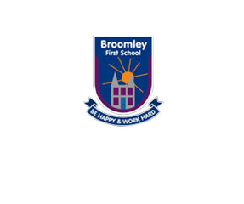
Federation of Whittonstall and Broomley First Schools
Year 4 Common Exception Word Lists
Green and Orange Group

 | Autumn 1 | Autumn 2 | Spring 1 | Spring 2 | Summer 1 | Summer 2
1 | behind | after | again | behind | again | after
2 | because | bath | any | because | any | bath
3 | both | beautiful | busy | both | busy | beautiful
4 | child | class | clothes | child | clothes | class
5 | children | everybody | could | children | could | everybody
6 | climb | every | eye | climb | eye | every
7 | cold | fast | half | cold | half | fast
8 | door | father | should | door | should | father
9 | floor | glass | whole | floor | whole | glass
10 | find | hour | who | find | who | hour
11 | gold | improve | Mr | gold | Mr | improve
12 | hold | last | Mrs | hold | Mrs | last
13 | kind | pass | sure | kind | sure | pass
14 | most | plant | sugar | most | sugar | plant
15 | poor | prove | money | poor | money | prove
16 | told | move | parents | told | parents | move
17 | mind | path | people | mind | people | path
18 | old | past | many | old | many | past
19 | only | pretty | would | only | would | pretty
20 | wild | steak | water | wild | water | steak

